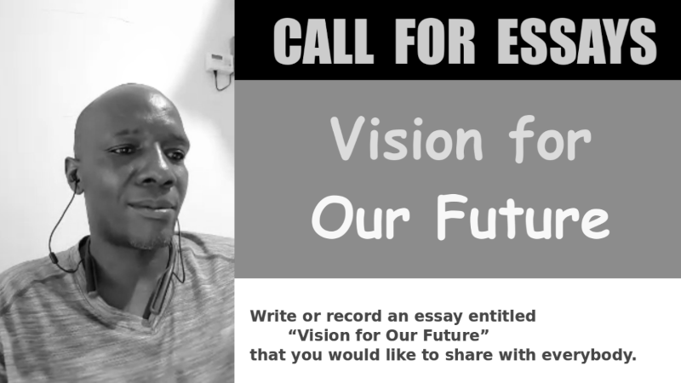

Write or record an essay entitled “Vision for Our Future” that you would like to share with everybody. Please post your essay on the internet and share it with your friends. Help others publish essays. Write or record your essay in any language. Use tags such as #OurFuture #Нашебудущее #Нашемайбутнє if you would like to organize with others. You do not have to answer the questions below, but they may help you reflect on your ideas. You are welcome to write about yourself as well.

**Questions**

* Who are we? Who would you mean by "we"? What groups do you want to identify with?

* What do you want us to be responsible for? How do you want us to make decisions? What should we strive for? What positive examples in history inspire you?

* What is the type of peace that you do and do not value? What is the type of conflict that you do and do not value?

* What are the causes of peace and conflict? Specifically, how can we prevent wars from happening? How can we end ongoing wars? What positive examples in history can we learn from?

* What are the issues, challenges, and opportunities that we should focus on?

* Russia and Ukraine are fighting over territory that they both claim. What do you suggest we do about that individually and collectively?

**Contact** Bill Pahl +370 606 23 389, bill_pahl@hotmail.com, or Andrius Kulikauskas +370 607 27 665, math4wisdom@gmail.com for more information. Let them know if you would like to attend the planning meeting on Tuesday, April 16, 19:00, or the presentation on Saturday, April 29, at Reforum Space at Užupio g.14, Vilnius, near the Užupis angel.